digital lock system

Final Project

Digital Logic Laboratory

Table of Contents

Table of Tables 2

Table of Figures 2

Abstract 3

Introduction 3

Design 3

Equipment and Programs 3

Block Diagram and Module Break Down 3

Top Module 3

Buttons 4

Block Diagram 4

Code 5

Counter Module 6

Code 6

Display Module 6

Code 7

Finite State Machine (FSM) Module 9

States 9

Reset 9

State Diagram 10

Table Diagram 10

Code 11

Constraints 17

Code 17

Test Bench 19

Scenarios 19

Results 20

Conclusion 22

# Table of Tables

Table 1 Table Diagram of FSM 10

# Table of Figures

Figure 1 button representation on Nexys 4 Board 4

Figure 2 Top module schematic 4

Figure 3 State Diagram of FSM 10

Figure 4 Right from the first try 19

Figure 5 Right from second try 19

Figure 6 Wrong twice 20

Figure 7 Output 1 20

Figure 8 Output 2 21

Figure 9 Output 3 22

# Abstract

Design a three digit combinational digital lock and implement it using the **Nexys4 board**. The lock system has five input buttons each representing an integer number, two led lights representing the two states of the system “locked” and “unlocked” and a seven segment display that displays the entered input and number of tries. To unlock the system, the user should enter the combinational lock key “241”. He will have two tries to enter the right key or else the system will stay locked.

# Introduction

The lock system is comprised of three main modules; Counter module, display module, and finite state machine (FSM) module. The system can be in two states “locked” and “unlocked”. The top module is responsible for the connections between the three main modules and the inputs and outputs of the system. The test-bench module tests different inputs/outputs of the finite state machine (FSM) module.

# Design

## Equipment and Programs

* Nexys 4 board
* Vivado Design Suite (VDS) software
* A computer

## Block Diagram and Module Break Down

## Top Module

This module pieces all of the other modules together to get the full lock system. It receives information directly from the push buttons (BTNU / BTNR / BTNC BTNL / BTND) and passes them to the FSM module. It connects the clock received from the system to the Counter Module. It manages the inputs and outputs between the components. It passes the output from the display module to the seven segment display.

### Buttons

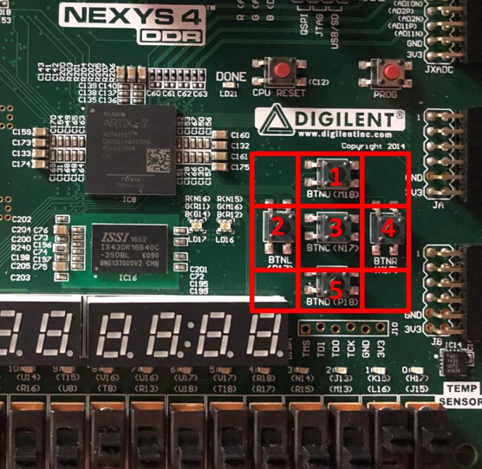

Figure button representation on Nexys 4 Board

Each button represents a digit

* BTNU = 1
* BTNL = 2
* BTNC = 3
* BTNR = 4
* BTND = 5

### Block Diagram

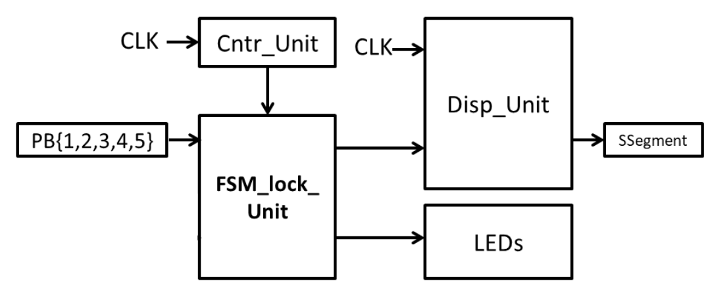

Figure Top module schematic

### Code

***module digital_lock (***

***input wire clk ,***

***input wire reset ,***

***input wire d1 ,***

***input wire d2 ,***

***input wire d3 ,***

***input wire d4 ,***

***input wire d5 ,***

***output wire unlock,***

***output wire lock ,***

***output wire [3:0] an ,***

***output wire [7:0] sseg***

***);***

***wire [2:0] disp_1_wire ;***

***wire [2:0] disp_2_wire ;***

***wire [2:0] disp_3_wire ;***

***wire [2:0] disp_N_wire ;***

***wire new_clk_wire;***

***Cntr_Unit Cntr (.clk(clk), .reset(reset), .new_clk(new_clk_wire));***

***FSM_lock_Unit FSM_lock (***

***.clk (new_clk_wire),***

***.lock (lock ),***

***.unlock(unlock ),***

***.disp_1(disp_1_wire ),***

***.disp_2(disp_2_wire ),***

***.disp_3(disp_3_wire ),***

***.disp_N(disp_N_wire ),***

***.reset (reset ),***

***.d1 (d1 ),***

***.d2 (d2 ),***

***.d3 (d3 ),***

***.d4 (d4 ),***

***.d5 (d5 )***

***);***

***Disp_Unit Disp (***

***.clk (clk ),***

***.reset (reset ),***

***.disp_1(disp_1_wire),***

***.disp_2(disp_2_wire),***

***.disp_3(disp_3_wire),***

***.disp_N(disp_N_wire),***

***.sseg (sseg ),***

***.an (an )***

***);***

***endmodule***

## Counter Module

This module slows down the FPGA internal clock from 100MHz to 10Hz. It takes the system’s clock as input and according to a counter register it either outputs “HIGH” when it reaches a value of 10,000,000 or “LOW” otherwise.

### Code

***module Cntr_Unit (***

***input clk ,***

***input reset ,***

***output reg new_clk***

***);***

***reg [31:0] r_reg;***

***always @ (posedge clk, posedge reset)begin***

***if (reset) begin***

***r_reg <= 0;***

***new_clk <= 0;***

***end else begin***

***if (r_reg == 50000000) begin //10000000***

***new_clk <= ~new_clk;***

***r_reg <= 0;***

***end else begin***

***new_clk <= new_clk;***

***r_reg <= r_reg + 1;***

***end***

***end***

***end***

***endmodule***

## Display Module

The display module will use the Seven Segment Display (SSD) to display the three values of the pressed buttons and the number of the users tries. The SSD is low level sensitive, meaning they light up when they are “LOW”. The module accepts the binary data for seven segment displays and decodes it using time division multiplexing.

### Code

***module Disp_Unit (***

***input [2:0] disp_1,***

***input [2:0] disp_2,***

***input [2:0] disp_3,***

***input [2:0] disp_N,***

***input reset ,***

***input clk ,***

***output reg [7:0] sseg ,***

***output reg [3:0] an***

***);***

***localparam N = 18;***

***reg [N-1:0] q_reg ;***

***wire [N-1:0] q_next ;***

***reg [ 2:0] disp_in ;***

***always @ ( posedge clk, posedge reset)***

***if (reset)***

***q_reg <= 0;***

***else***

***q_reg <= q_next;***

***assign q_next = q_reg + 1;***

***always @\****

***case (q_reg [N-1:N-2])***

***2'b00 :***

***begin***

***an = 4'b1110;***

***disp_in = disp_1;***

***end***

***2'b01 :***

***begin***

***an = 4'b1101;***

***disp_in = disp_2;***

***end***

***2'b10 :***

***begin***

***an = 4'b1011;***

***disp_in = disp_3;***

***end***

***default :***

***begin***

***an = 4'b0111;***

***disp_in = disp_N;***

***end***

***endcase***

***always @\****

***begin***

***case (disp_in)***

***3'b000 : sseg[6:0] = 7'b1000000 ;***

***3'b001 : sseg[6:0] = 7'b1111001 ;***

***3'b010 : sseg[6:0] = 7'b0100100 ;***

***3'b011 : sseg[6:0] = 7'b0110000 ;***

***3'b100 : sseg[6:0] = 7'b0011001 ;***

***3'b101 : sseg[6:0] = 7'b0010010 ;***

***default : sseg[6:0] = 7'b1000000 ;***

***endcase***

***sseg[7] = 1'b1;***

***end***

***endmodule***

## Finite State Machine (FSM) Module

### States

The FSM has eight states:

### Reset

Initializes the system and sets the state register to the initial state “A”.

#### State A

* Resets everything but the number of tries to the following initial conditions:

1. Unlock led turned off
2. Lock led turned on
3. First display to zero
4. Second display to zero
5. Third display to zero

* It transitions into state “B” if the first input was equal to “2” or state “E” otherwise

#### State B

* sets the first display to the first input value
* It transitions into state “C” if the second input was equal to “4” or state “F” otherwise

#### State C

* sets the second display to the second input value
* It transitions into state “D” if the third input was equal to “1” or state “G” otherwise

#### State D

* sets the third display to the third input value
* Sets the unlock led to “HIGH”
* The system stays at this state

#### State E

* sets the first display to the first input value
* It transitions into state “F” once the second input is entered

#### State F

* sets the second display to the second input value
* It transitions into state “G” once the third input is entered

#### State G

* sets the third display to the third input value
* increments the number of tries “N”
* It transitions into state “H” if the number of tries “N” is less than two or state “A” otherwise.

#### State H

* sets lock led to “HIGH”
* The system stays at this state

### State Diagram

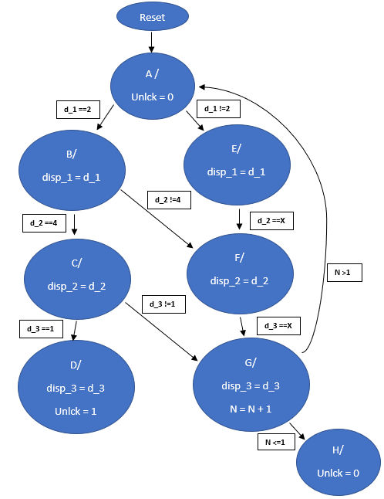

Figure State Diagram of FSM

### Table Diagram

|  |  |  |  |  |  |  |  |  |  |  |  |  |  |  |  |  |
| --- | --- | --- | --- | --- | --- | --- | --- | --- | --- | --- | --- | --- | --- | --- | --- | --- |
| **Current**  **state** | **Next State** | | | | | | | | | | **Output** | | | | | |
|  | **d_1** | | **d_2** | | | **d_3** | | | **N** | | **disp_1** | **disp_2** | **disp_3** | **N** | unlock | lock |
| **2** | **!2** | **4** | **!4** | **X** | **1** | **!1** | **X** | **<=1** | **>1** |
| **A** | **B** | **E** | **-** | **-** | **-** | **-** | **-** | **-** | **-** | **-** | **0** | **0** | **0** | **N** | **0** | **0** |
| **B** | **-** | **-** | **C** | **F** | **-** | **-** | **-** | **-** | **-** | **-** | **d_1** | **0** | **0** | **N** | **0** | **0** |
| **C** | **-** | **-** | **-** | **-** | **-** | **D** | **G** | **-** | **-** | **-** | **d_1** | **d_2** | **0** | **N** | **0** | **0** |
| **D** | **-** | **-** | **-** | **-** | **-** | **-** | **-** | **-** | **-** | **-** | **d_1** | **d_2** | **d_3** | **N** | **1** | **0** |
| **E** | **-** | **-** | **-** | **-** | **F** | **-** | **-** | **-** | **-** | **-** | **d_1** | **0** | **0** | **N** | **0** | **0** |
| **F** | **-** | **-** | **-** | **-** | **-** | **-** | **-** | **G** | **-** | **-** | **d_1** | **d_2** | **0** | **N** | **0** | **0** |
| **G** | **-** | **-** | **-** | **-** | **-** | **-** | **-** | **-** | **H** | **A** | **d_1** | **d_2** | **d_3** | **N - 1** | **0** | **0** |
| **H** | **-** | **-** | **-** | **-** | **-** | **-** | **-** | **-** | **-** | **-** | **d_1** | **d_2** | **d_3** | **N** | **0** | **1** |

Table Table Diagram of FSM

### Code

***module FSM_lock_Unit (***

***input clk ,***

***input d1 ,***

***input d2 ,***

***input d3 ,***

***input d4 ,***

***input d5 ,***

***output reg lock ,***

***output reg unlock,***

***output reg [2:0] disp_1,***

***output reg [2:0] disp_2,***

***output reg [2:0] disp_3,***

***output reg [2:0] disp_N,***

***input reset***

***);***

***parameter [2:0] A = 3'b000, B = 3'b001, C = 3'b010, D = 3'b011,E = 3'b100, F = 3'b101, G = 3'b110, H = 3'b111;***

***reg [2:0] N ;***

***reg [2:0] N_r ;***

***reg [2:0] state_next;***

***reg [2:0] state_reg ;***

***reg [2:0] disp_1_r;***

***reg [2:0] disp_2_r;***

***reg [2:0] disp_3_r;***

***reg [2:0] disp_N_r;***

***reg lock_r;***

***reg unlock_r;***

***reg d1_r;***

***reg d2_r;***

***reg d3_r;***

***reg d4_r;***

***reg d5_r;***

***wire d1_flag;***

***wire d2_flag;***

***wire d3_flag;***

***wire d4_flag;***

***wire d5_flag;***

***always @(posedge clk or posedge reset) begin***

***if(reset) begin***

***d1_r <= 0;***

***d2_r <= 0;***

***d3_r <= 0;***

***d4_r <= 0;***

***d5_r <= 0;***

***end else begin***

***d1_r <= d1;***

***d2_r <= d2;***

***d3_r <= d3;***

***d4_r <= d4;***

***d5_r <= d5;***

***end***

***end***

***assign d1_flag = ~d1_r & d1;***

***assign d2_flag = ~d2_r & d2;***

***assign d3_flag = ~d3_r & d3;***

***assign d4_flag = ~d4_r & d4;***

***assign d5_flag = ~d5_r & d5;***

***always @ ( posedge clk or posedge reset)***

***if (reset)***

***state_reg <= A;***

***else***

***state_reg <= state_next;***

***always @ ( posedge clk or posedge reset)***

***if (reset) begin***

***N_r <= 2;***

***disp_1_r <= 0;***

***disp_2_r <= 0;***

***disp_3_r <= 0;***

***disp_N_r <= 2;***

***unlock_r <= 0;***

***lock_r <= 0;***

***end else begin***

***N_r <= N;***

***disp_1_r <= disp_1;***

***disp_2_r <= disp_2;***

***disp_3_r <= disp_3;***

***disp_N_r <= disp_N;***

***unlock_r <= unlock;***

***lock_r <= lock;***

***end***

***always @(state_reg, d1_flag, d2_flag, d3_flag, d4_flag, d5_flag) begin***

***disp_1 = disp_1_r;***

***disp_2 = disp_2_r;***

***disp_3 = disp_3_r;***

***disp_N = disp_N_r;***

***unlock = unlock_r;***

***lock = lock_r;***

***N = N_r;***

***state_next = state_reg;***

***case (state_reg)***

***A :***

***begin***

***disp_1 = 3'b000;***

***disp_2 = 3'b000;***

***disp_3 = 3'b000;***

***if (d2_flag)***

***begin***

***disp_1 = 3'b010;***

***state_next = B;***

***end***

***else***

***begin***

***if (d1_flag) begin***

***disp_1 = 3'b001;***

***state_next = E;***

***end else if (d3_flag) begin***

***disp_1 = 3'b011;***

***state_next = E;***

***end else if (d4_flag) begin***

***disp_1 = 3'b100;***

***state_next = E;***

***end else if (d5_flag) begin***

***disp_1 = 3'b101;***

***state_next = E;***

***end***

***end***

***end***

***B :***

***begin***

***if (d4_flag)***

***begin***

***disp_2 = 3'b100;***

***state_next = C;***

***end***

***else***

***begin***

***if (d1_flag) begin***

***disp_2 = 3'b001;***

***state_next = F;***

***end else if (d2_flag) begin***

***disp_2 = 3'b010;***

***state_next = F;***

***end else if (d3_flag) begin***

***disp_2 = 3'b011;***

***state_next = F;***

***end else if (d5_flag) begin***

***disp_2 = 3'b101;***

***state_next = F;***

***end***

***end***

***end***

***C :***

***begin***

***if (d1_flag)***

***begin***

***disp_3 = 3'b001;***

***state_next = D;***

***end***

***else***

***begin***

***if (d4_flag) begin***

***disp_3 = 3'b100;***

***state_next = G;***

***end else if (d2_flag) begin***

***disp_3 = 3'b010;***

***state_next = G;***

***end else if (d3_flag) begin***

***disp_3 = 3'b011;***

***state_next = G;***

***end else if (d5_flag) begin***

***disp_3 = 3'b101;***

***state_next = G;***

***end***

***end***

***end***

***D :***

***begin***

***unlock = 1;***

***lock = 0;***

***end***

***E :***

***begin***

***if (d1_flag) begin***

***disp_2 = 3'b001;***

***state_next = F;***

***end else if (d4_flag) begin***

***disp_2 = 3'b100;***

***state_next = F;***

***end else if (d2_flag) begin***

***disp_2 = 3'b010;***

***state_next = F;***

***end else if (d3_flag) begin***

***disp_2 = 3'b011;***

***state_next = F;***

***end else if (d5_flag) begin***

***disp_2 = 3'b101;***

***state_next = F;***

***end***

***end***

***F :***

***begin***

***if (d1_flag) begin***

***disp_3 = 3'b001;***

***state_next = G;***

***end else if (d4_flag) begin***

***disp_3 = 3'b100;***

***state_next = G;***

***end else if (d2_flag) begin***

***disp_3 = 3'b010;***

***state_next = G;***

***end else if (d3_flag) begin***

***disp_3 = 3'b011;***

***state_next = G;***

***end else if (d5_flag) begin***

***disp_3 = 3'b101;***

***state_next = G;***

***end***

***end***

***G :***

***begin***

***N = N_r - 1;***

***disp_N = N_r - 1;***

***if (N_r > 1)***

***state_next = A;***

***else***

***begin***

***state_next = H;***

***unlock = 0;***

***lock = 1;***

***end***

***end***

***H :***

***begin***

***unlock = 0;***

***lock = 1;***

***end***

***endcase***

***end***

***endmodule***

## Constraints

This is used for Hardware interfacing. It specifies the mapping of the FPGAs pins to other parts on the board and gives them names and some context.

### Code

***## Clock signal***

***set_property -dict { PACKAGE_PIN E3 IOSTANDARD LVCMOS33 } [get_ports { clk }]; #IO_L12P_T1_MRCC_35 Sch=clk100mhz***

***create_clock -add -name sys_clk_pin -period 10.00 -waveform {0 5} [get_ports {clk}];***

***##Switches***

***set_property -dict { PACKAGE_PIN J15 IOSTANDARD LVCMOS33 } [get_ports { reset }]; #IO_L24N_T3_RS0_15 Sch=sw[0]***

***## LEDs***

***set_property -dict { PACKAGE_PIN H17 IOSTANDARD LVCMOS33 } [get_ports { unlock }]; #IO_L18P_T2_A24_15 Sch=led[0]***

***set_property -dict { PACKAGE_PIN K15 IOSTANDARD LVCMOS33 } [get_ports { lock }]; #IO_L24P_T3_RS1_15 Sch=led[1]***

***##7 segment display***

***set_property -dict { PACKAGE_PIN T10 IOSTANDARD LVCMOS33 } [get_ports { sseg[0] }]; #IO_L24N_T3_A00_D16_14 Sch=ca***

***set_property -dict { PACKAGE_PIN R10 IOSTANDARD LVCMOS33 } [get_ports { sseg[1] }]; #IO_25_14 Sch=cb***

***set_property -dict { PACKAGE_PIN K16 IOSTANDARD LVCMOS33 } [get_ports { sseg[2] }]; #IO_25_15 Sch=cc***

***set_property -dict { PACKAGE_PIN K13 IOSTANDARD LVCMOS33 } [get_ports { sseg[3] }]; #IO_L17P_T2_A26_15 Sch=cd***

***set_property -dict { PACKAGE_PIN P15 IOSTANDARD LVCMOS33 } [get_ports { sseg[4] }]; #IO_L13P_T2_MRCC_14 Sch=ce***

***set_property -dict { PACKAGE_PIN T11 IOSTANDARD LVCMOS33 } [get_ports { sseg[5] }]; #IO_L19P_T3_A10_D26_14 Sch=cf***

***set_property -dict { PACKAGE_PIN L18 IOSTANDARD LVCMOS33 } [get_ports { sseg[6] }]; #IO_L4P_T0_D04_14 Sch=cg***

***set_property -dict { PACKAGE_PIN H15 IOSTANDARD LVCMOS33 } [get_ports { sseg[7] }]; #IO_L19N_T3_A21_VREF_15 Sch=dp***

***set_property -dict { PACKAGE_PIN J17 IOSTANDARD LVCMOS33 } [get_ports { an[0] }]; #IO_L23P_T3_FOE_B_15 Sch=an[0]***

***set_property -dict { PACKAGE_PIN J18 IOSTANDARD LVCMOS33 } [get_ports { an[1] }]; #IO_L23N_T3_FWE_B_15 Sch=an[1]***

***set_property -dict { PACKAGE_PIN T9 IOSTANDARD LVCMOS33 } [get_ports { an[2] }]; #IO_L24P_T3_A01_D17_14 Sch=an[2]***

***set_property -dict { PACKAGE_PIN J14 IOSTANDARD LVCMOS33 } [get_ports { an[3] }]; #IO_L19P_T3_A22_15 Sch=an[3]***

***##Buttons***

***set_property -dict { PACKAGE_PIN N17 IOSTANDARD LVCMOS33 } [get_ports { d3 }]; #IO_L9P_T1_DQS_14 Sch=btnc***

***set_property -dict { PACKAGE_PIN M18 IOSTANDARD LVCMOS33 } [get_ports { d1 }]; #IO_L4N_T0_D05_14 Sch=btnu***

***set_property -dict { PACKAGE_PIN P17 IOSTANDARD LVCMOS33 } [get_ports { d2 }]; #IO_L12P_T1_MRCC_14 Sch=btnl***

***set_property -dict { PACKAGE_PIN M17 IOSTANDARD LVCMOS33 } [get_ports { d4 }]; #IO_L10N_T1_D15_14 Sch=btnr***

***set_property -dict { PACKAGE_PIN P18 IOSTANDARD LVCMOS33 } [get_ports { d5 }]; #IO_L9N_T1_DQS_D13_14 Sch=btnd***

## Test Bench

The test-bench module tests the finite state machine (FSM) module. It can be used to assign inputs to the FSM and examine its outputs accordingly. Enables us to create different scenarios and stimulate the results.

### Scenarios

There are three possible scenarios:

1. The user enters the right combinational key

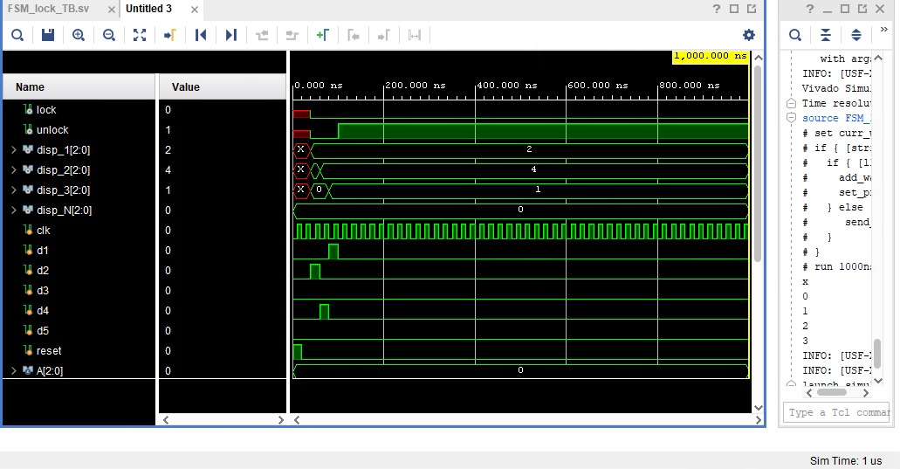

Figure Right from the first try

1. The user enters the wrong followed by the right combinational key

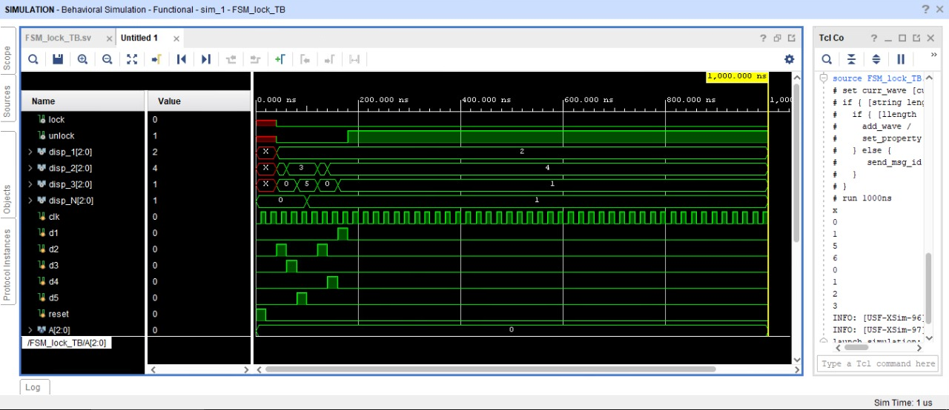

Figure Right from second try

1. The user enters the wrong combinational key twice in a row

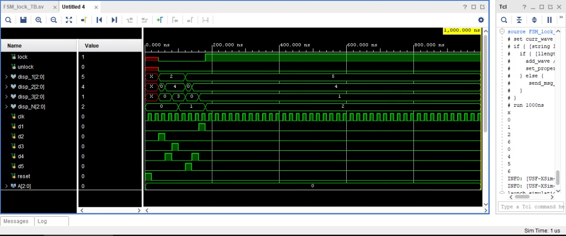

Figure Wrong twice

# Results

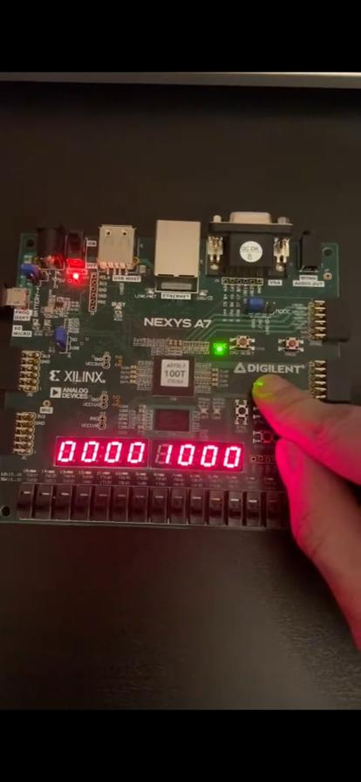

Figure Output 1

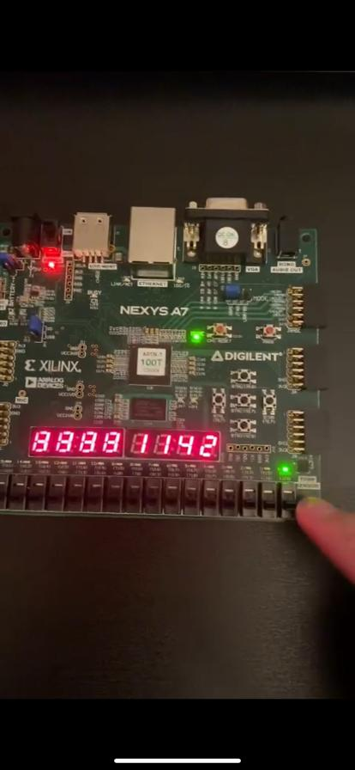

Figure Output 2

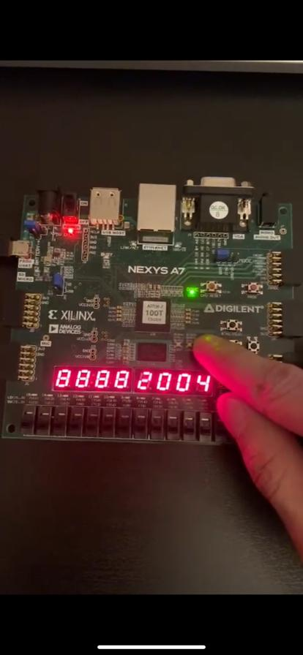

Figure Output 3

# Conclusion

The experimental results, theoretical results, and simulation results are identical as expected. Initially the digital lock displays zeros for the first, second and third digits and it diplays 1 for the number of remaining tries. Then The digital lock displays the decimal digits of the buttons as they are pressed. The number of tries decrements once the user enters the wrong lock key. The unlock led turns on when the user enters the right lock key and stays at that state no matter the buttons pressed. The lock led turns on when the user enters the wrong lock key twice in a row and stays at that state no matter the buttons pressed.